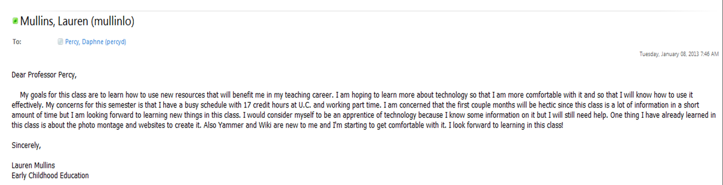

This is an example of how a professional e-mail should look, however I took out my personal information.

